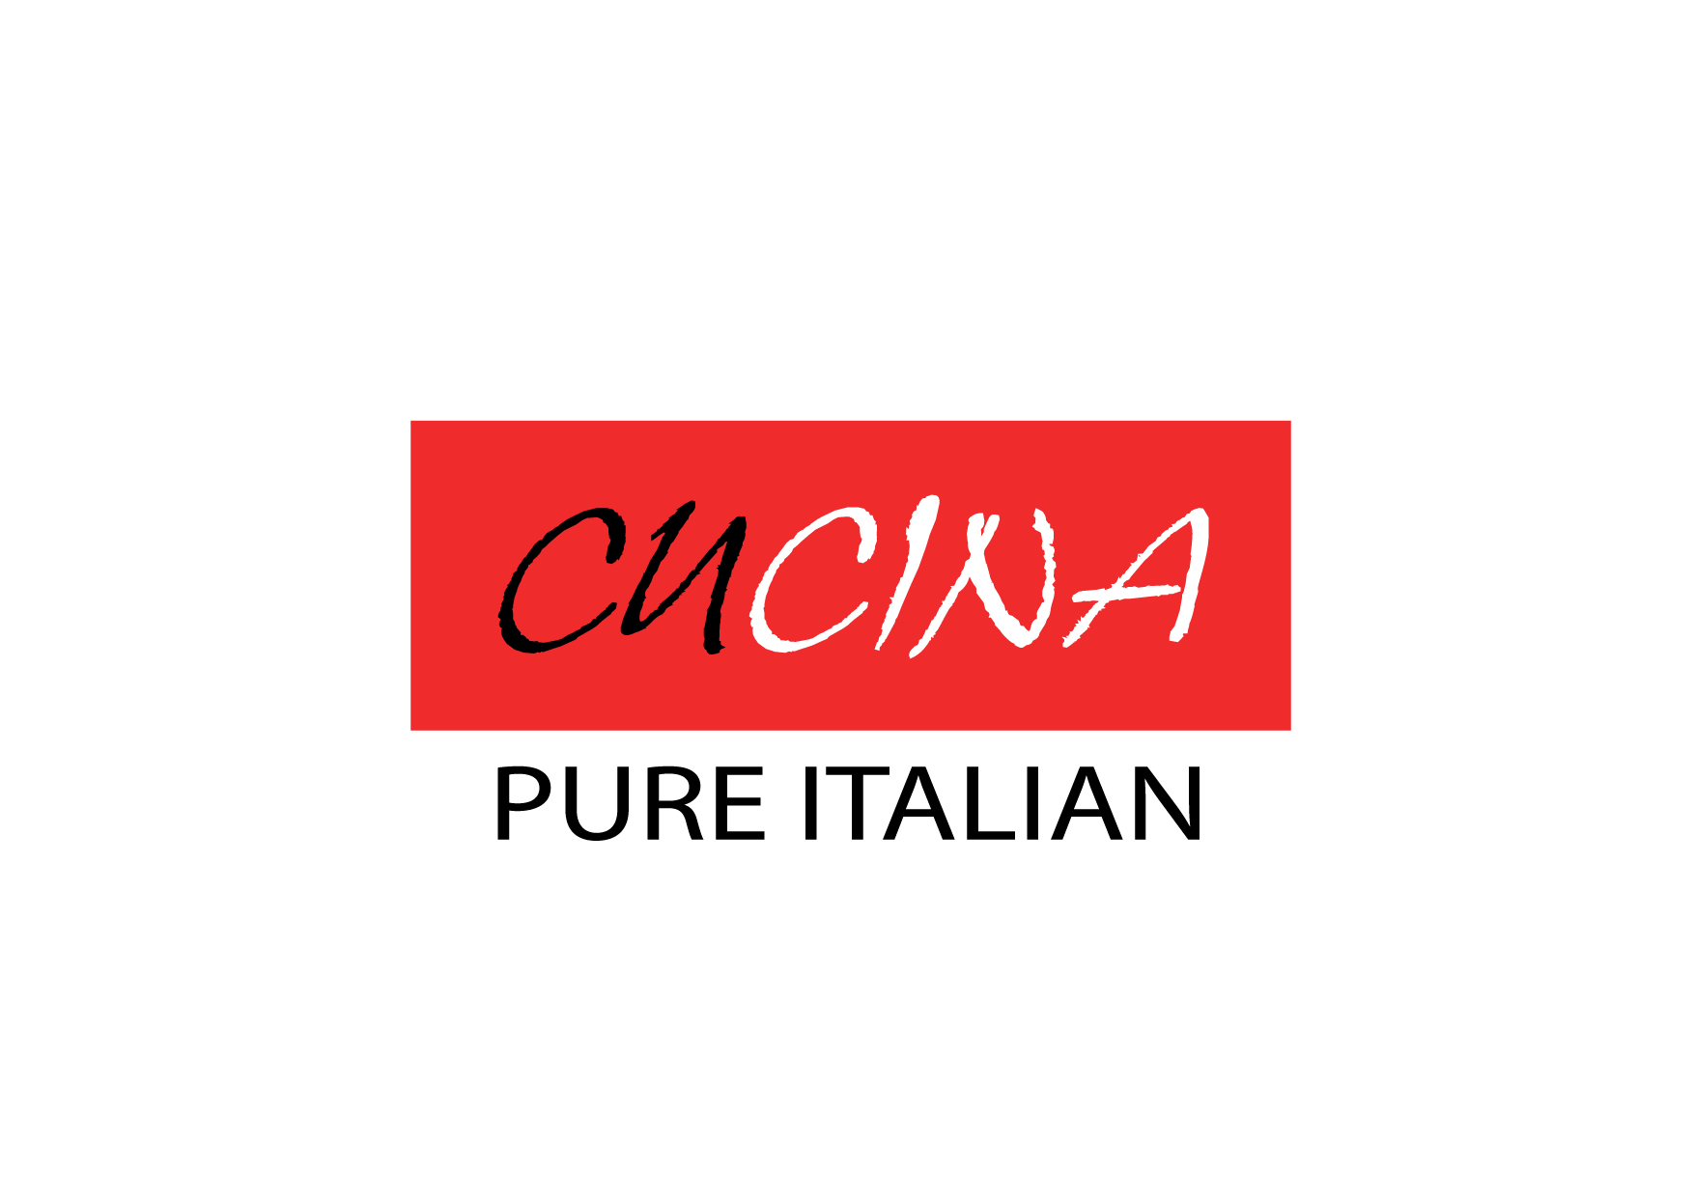


St. Valentine’s Dinner Menu

Capesante scottate, fegato d’anatra, salsa all’ avocado, mango, caviale di yuzu
Seared Hokkaido scallop and duck liver, avocado salsa, mango, yuzu caviar
香煎北海道帶子及鴨肝伴牛油果莎莎, 芒果及柚子魚子醬
○ ◦ ○ ◦ ○ ◦ ○ ◦ ○
Sorbetto al Perrier jouet e rosa
Perrier jouet and rose sorbet
巴黎之花香檳及玫瑰雪葩
○ ◦ ○ ◦ ○ ◦ ○ ◦ ○
Ravioli ai funghi porcini, salsa all’ astice , asparagi e tartufo
Porcini mushrooms ravioli, Boston lobster, asparagus, truffle
意式牛肝菌雲吞伴波士頓龍蝦及松露, 露荀
○ ◦ ○ ◦ ○ ◦ ○ ◦ ○
Filetto di salmone, barbabietola, mela, pure’ di piselli e agretti al limone
Fillet of salmon, dehydrated beetroot and apple, green pea pure’, monk's beard
三文魚柳伴風乾紅菜頭蘋果青豆蓉及豬毛菜
Or

Sottofiletto di manzo, pure’ si carota allo zenzero, salsa al banyuls
Baked US prime beef sirloin, carrot and ginger puree, banyuls sauce
焗美國頂級西冷伴紅蘿蔔, 生薑蓉及夏伯帝甜酒汁
○ ◦ ○ ◦ ○ ◦ ○ ◦ ○
L amore e’ nell aria
Chocolate mousse with rose and lychee jelly
玫瑰朱古力慕絲及荔枝啫喱

$1,988+10% per couple including two glasses of Bellavizio Bordeaux Rosé Wine 2015

$2,500+10% per couple including a bottle of Bellavizio Bordeaux Rosé Wine 2015

